Notable Observations:

1) Yes, there is a growing trend on e-commerce in Brazil. On doing year by year analysis of 'orders successfully delivered’ it can be seen that there is a significant growth of orders from 2016 into 2017 and while maintaining the 2017 orders there is again growth in 2018. Yes some seasonality peak is also being noticed between months November to March, mainly in Winter season.

2) There is not a lot to separate from the number of orders placed in the working hours (i.e 0900 hrs to 2200 hrs) . Although there is a big rise in orders from around 0800-0900 hrs in the morning till 1600 hrs in the afternoon then there is a little decline but it again picks up at 1900 hrs and continues growing till 2200 hrs in the night. Therefore, dawn and mid night are the times when Brazilians' buy least.

3) The distribution of customers across Brazil states-wise is pretty uneven with top 3 states being SP, RJ & MG with 41746,12852 & 11635 number of customers respectively and lowest 3 states being RR, AP & AC with 46,61 & 81 no of customers respectively.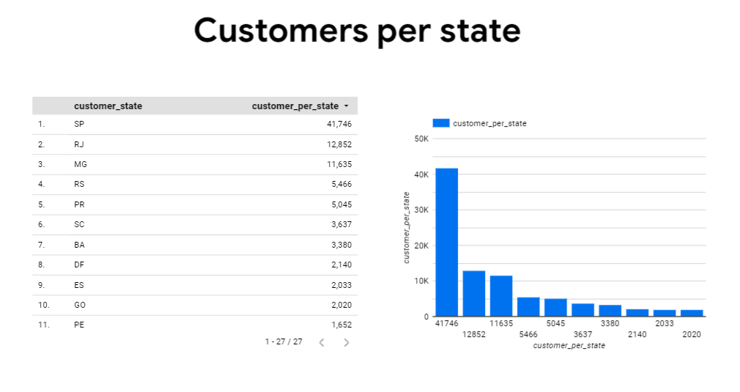

4) Money movement through e-commerce has increased significantly and precisely by 137% from 2017 in 2018.

5) The avg. price of product across different states ranges from 110 to 191 while the avg. freight value varies from 15 to 43.

6) Usually, all the orders are delivered before the estimated delivery date. There are negligible number of times when delivery has happened after the estimated date.

7) Average time taken for the delivery of orders ranges from 9 to 28 days across different states in the country. And as observed in the 1st part of this question most orders are delivered before the estimated delivery date, the average difference between estimated and actual delivery date is positive and ranges from 9 to 21 days which means the orders are delivered between 9 to 21 days before the estimated date across states.

8) The most used payment method is credit card then UPIs then vouchers and the least used is debit cards.

Actionable Insights -

1.Since we saw a seasonality peak between months November to March, Target can put out some offers for customers during the "off seasons" or introduce some season specific products so that there can be equal orders across the year.

2. Since there are low sales at dawn and mid night time, the events like flash sales can be held during those hours with prior advertisements about the event.

3. In some states the average delivery time is more than 20 days which is too high for a customer's likings. This can be addressed by setting up some more delivery stations and warehouses or can set up some new delivery channels which can reduce delivery days.

Recommendation -

1. The uneven distribution of customers across the states in Brazil should be looked upon in more detail because the difference between highest (41746 customers for SP) and lowest (46 customers for RR state) is pretty big.

2. With increasing average cost of orders the freight value also should increase naturally as more transportation will be used but, in the analysis, its seen that in some cases increase in price mean does not necessarily increase mean freight value for a state when compared to other states, this should be uniform and the reason why freight value increase for some states and not for others should be looked upon.